Title

AIR QUALITY INDEX PREDICTION USING MACHINE LEARNING

A Report Submitted to the
Gujarat Technological University
In Partial fulfillment of the requirements for the degree of
Master of Computer Application

BY

NANDINI KATHIRIYA - 245030694044
DIXIT BHESANIYA - 245030694007
DARSHAN UBHADIYA - 245030694100



Department of Master of Computer Application
B.H. GARDI COLLEGE OF ENGINEERING & TECHNOLOGY Rajkot, Gujarat (India)
November - 2025

Content
INDEX

Sr. No | Content | Page No.
1 | Abstract | 1
2 | Introduction
2.1 | Background of the Study
2.2 | Significance of the Project

Abstract

This project focuses on developing a Machine Learning model for predicting the Air Quality Index (AQI), a critical indicator of air pollution levels, vital for public health and environmental management. Utilizing historical air quality data from various Indian cities (sourced from Kaggle's city_day.csv dataset), the project aims to forecast AQI based on concentrations of key pollutants such as PM2.5, PM10, NO, NO2, NOx, NH3, CO, SO2, O3, Benzene, Toluene, and Xylene.

The methodology involves a comprehensive data preprocessing pipeline, including robust handling of missing values (by mean imputation) and feature scaling using StandardScaler to prepare the data for modeling. A RandomForestRegressor model was selected and trained on the preprocessed historical data.

The model's performance was rigorously evaluated using standard regression metrics on an unseen test set, yielding impressive results: a Mean Absolute Error (MAE) of approximately 18.47, a Mean Squared Error (MSE) of 1070.42, a Root Mean Squared Error (RMSE) of 32.72, and an outstanding R-squared (R2 Score) of 0.90. This high R2 score indicates that the model can explain approximately 90% of the variance in AQI, demonstrating its strong predictive capability.

The project successfully demonstrates the application of Machine Learning to provide accurate AQI forecasts. This can aid in issuing timely public health advisories, supporting environmental policy-making, and fostering data-driven decisions for pollution control and a healthier environment.

Introduction

Air pollution stands as one of the most pressing global environmental and public health challenges of the 21st century. Rapid industrialization, urbanization, and increasing vehicular traffic have led to a significant deterioration of air quality in numerous regions worldwide, including major cities across India. This pervasive problem has severe consequences, ranging from chronic respiratory and cardiovascular diseases to environmental degradation and climate change impacts.
The Air Quality Index (AQI) serves as a critical and standardized metric designed to communicate the level of air pollution and its associated health risks to the public. It converts complex air quality data from various pollutants into a single, easily understandable numerical value and corresponding descriptive category (e.g., Good, Satisfactory, Moderately Polluted, Poor, Very Poor, Severe). This tool empowers individuals to make informed decisions regarding their outdoor activities and helps public health officials issue timely advisories.
Accurate and timely prediction of AQI is of paramount importance. Such forecasts enable proactive measures rather than reactive responses to air pollution episodes. For instance, anticipating periods of poor air quality allows authorities to implement pollution control strategies, manage traffic, or advise sensitive populations to take precautions. Traditionally, air quality forecasting relied on complex atmospheric chemistry and meteorological models, which are often computationally intensive, require extensive domain expertise, and can be challenging to adapt to diverse local conditions.
In recent years, Machine Learning (ML) has emerged as a powerful and versatile tool for addressing complex predictive problems across various domains. By leveraging vast amounts of historical air quality data, ML algorithms can identify intricate, non-linear patterns and relationships between pollutant concentrations, meteorological factors, and the resulting AQI. This data-driven approach offers a promising alternative to traditional modeling, providing the potential for more efficient, scalable, and accurate AQI predictions.
This project embarks on the development of a Machine Learning-based system to predict the Air Quality Index. By meticulously processing historical air quality data and employing a robust ML model, we aim to deliver an effective tool capable of forecasting AQI, thereby contributing to informed decision-making for a healthier environment and improved public well-being.

Background of the Study

The escalation of air pollution has become a critical concern on a global scale, particularly evident in rapidly developing nations. Countries like India are experiencing unprecedented rates of industrialization, urbanization, and population growth, which, while driving economic progress, have inadvertently contributed to a severe degradation of air quality. Major Indian cities frequently report air pollution levels that significantly exceed national and international safety standards, leading to a host of detrimental effects on human health, ecosystems, and the overall quality of life.

Governmental and environmental agencies, such as the Central Pollution Control Board (CPCB) in India, have established extensive networks of air quality monitoring stations across various cities. These stations continuously collect data on the concentrations of key atmospheric pollutants, including particulate matter (PM2.5, PM10), nitrogen oxides (NO, NO2, NOx), carbon monoxide (CO), sulfur dioxide (SO2), ozone (O3), and volatile organic compounds (Benzene, Toluene, Xylene). This collected data is then used to calculate the Air Quality Index (AQI), which provides a simple, color-coded scale to inform the public about daily air quality status and potential health impacts.

The sheer volume and complexity of the data generated by these monitoring efforts present both a challenge and an opportunity. While traditional methods of air quality assessment and forecasting have relied on physico-chemical models that simulate atmospheric processes, these models often require extensive computational power and detailed meteorological inputs. The advancements in Machine Learning (ML) techniques, coupled with the increasing availability of historical air quality data, offer a promising alternative. ML models can learn intricate, non-linear patterns directly from the data, potentially providing more agile, efficient, and accurate predictions for air quality.

This study is set against this backdrop, aiming to leverage the power of Machine Learning to develop a predictive model for AQI using real-world historical data from Indian cities. By doing so, it seeks to contribute to the ongoing efforts to understand, predict, and ultimately mitigate the impacts of air pollution, thereby supporting public health initiatives and environmental sustainability goals.

Significance of the Project

The development of an accurate and robust Air Quality Index (AQI) prediction model using Machine Learning holds substantial significance across various domains:

- Public Health Protection: The most immediate and critical impact of this project lies in safeguarding public health. By providing timely and accurate AQI forecasts, the system can enable health organizations and authorities to issue early warnings to the public about anticipated poor air quality days. This allows vulnerable populations, such as children, the elderly, and individuals with respiratory or cardiovascular conditions, to take proactive measures like limiting outdoor activities, wearing masks, or seeking medical advice, thereby reducing their exposure to harmful pollutants and mitigating adverse health effects.

- Informed Environmental Policy and Management: Accurate AQI predictions can serve as a vital tool for environmental regulatory bodies and urban planners. Forecasts can inform policy decisions, such as implementing temporary restrictions on industrial emissions or vehicular traffic during periods of predicted high pollution. It aids in developing targeted interventions, assessing the effectiveness of existing environmental policies, and planning sustainable urban development that minimizes pollution.

- Enhanced Data-Driven Decision Making: This project showcases the power of Machine Learning in transforming raw environmental data into actionable insights. By uncovering complex, non-linear patterns within historical air quality data, the ML model provides a data-driven approach to understanding pollution dynamics that might be overlooked by traditional methods. This enhances the capacity for evidence-based decision-making in environmental monitoring and management.

- Resource Optimization: Knowing in advance when and where air quality is likely to deteriorate can help optimize the allocation of resources. For instance, air purifiers in public spaces, emergency medical services, or public awareness campaigns can be strategically deployed to areas most affected by predicted high pollution levels, leading to more efficient resource utilization.

- Increased Public Awareness and Empowerment: A user-friendly AQI prediction system can contribute to greater public awareness about local air quality conditions. By presenting complex pollutant data in an easily digestible AQI format, citizens are empowered to understand their environment better and make informed choices that protect their health and contribute to collective efforts for cleaner air.

In essence, this project transcends a mere academic exercise by offering a practical, data-driven solution to a critical real-world problem. It aims to harness cutting-edge technology to contribute to a healthier society and a more sustainable environment.

Problem Statement

The increasing levels of air pollution, particularly in urban centers, pose a significant and multifaceted challenge to human health, environmental sustainability, and economic development. While continuous monitoring provides current air quality data, the ability to accurately and reliably predict future air quality levels, specifically the Air Quality Index (AQI), remains a complex and critical undertaking. The core problem lies in developing an efficient and accurate predictive model that can effectively capture the dynamic and intricate interactions of various pollutants and other influencing factors to forecast AQI.

Current Challenges

Accurately predicting the Air Quality Index is fraught with several inherent challenges:

- Multivariate and Dynamic Nature: Air quality is influenced by a multitude of factors that interact in complex, non-linear ways. These include the concentrations of various primary and secondary pollutants (e.g., PM2.5, PM10, NO2, CO, O3), meteorological conditions (e.g., temperature, humidity, wind speed and direction, atmospheric pressure), topographical features, industrial emissions, vehicular traffic patterns, and seasonal variations. Capturing and modeling these dynamic and intricate relationships are highly challenging.

- Data Heterogeneity and Missing Values: Real-world air quality monitoring datasets often suffer from heterogeneity (data from different sensors, varying measurement frequencies) and a significant amount of missing data points (NaN values) due to sensor malfunctions, maintenance, or communication issues. Handling these missing values effectively without introducing bias or losing critical information is a crucial preprocessing challenge.

- Lack of Unified Predictive Frameworks: While traditional atmospheric chemistry models exist, they often require extensive computational resources, specialized expertise, and are difficult to calibrate and generalize across diverse geographical regions. Moreover, they may not always capture the local nuances and sudden fluctuations as effectively as data-driven models.

- Computational Intensity: Forecasting air quality using traditional physics-based models can be computationally very expensive, making real-time or rapid predictions challenging for widespread deployment.

Need for the Project

Given the aforementioned challenges and the critical implications of air pollution, there is a substantial and urgent need for an advanced, accessible, and accurate AQI prediction system. This project directly addresses this need by:

- Enabling Proactive Public Health Measures: An accurate predictive model allows public health officials to issue timely warnings, enabling vulnerable populations to take preventive measures and reducing public exposure to harmful pollutants.

- Supporting Environmental Policy and Decision Making: Reliable AQI forecasts can inform environmental regulatory bodies in formulating effective pollution control strategies, implementing short-term mitigation actions (e.g., traffic restrictions), and guiding long-term urban and industrial planning for sustainable development.

- Leveraging Data Science for Environmental Insight: By applying Machine Learning techniques, the project aims to extract valuable insights from large historical datasets, identifying the most influential factors contributing to AQI fluctuations and enhancing our scientific understanding of local air pollution dynamics.

- Developing an Efficient and Scalable Solution: Machine Learning models, once trained, can provide rapid predictions with relatively lower computational overhead compared to complex atmospheric models, making them suitable for widespread and potentially real-time deployment.

- Bridging the Gap in Existing Tools: This project provides a robust, data-driven framework that complements existing monitoring systems by adding a crucial predictive capability, moving from reactive reporting to proactive forecasting of air quality.

Objectives and Scope

This project is designed to address the challenges of predicting Air Quality Index (AQI) by leveraging the capabilities of Machine Learning. The objectives outline what the project aims to achieve, while the scope defines its boundaries and areas of focus, alongside recognizing its inherent limitations.

Project Objectives

The primary objectives of this "Air Quality Index Prediction using Machine Learning" project are:

- Data Acquisition and Preprocessing: To gather historical air quality data (specifically the city_day.csv dataset from Kaggle) and perform comprehensive preprocessing, including handling missing values through appropriate imputation techniques (mean imputation) and preparing the dataset for machine learning algorithms.

- Feature Engineering and Scaling: To identify relevant pollutant concentrations as features and apply feature scaling (StandardScaler) to normalize the data, ensuring optimal performance for the chosen machine learning model.

- Machine Learning Model Development: To select and implement a suitable supervised machine learning regression model, specifically a RandomForestRegressor, for predicting the numerical Air Quality Index (AQI).

- Model Training and Evaluation: To train the selected model on the prepared historical data and rigorously evaluate its performance using standard regression metrics such as Mean Absolute Error (MAE), Mean Squared Error (MSE), Root Mean Squared Error (RMSE), and R-squared (R2 Score) on an unseen test dataset.

- Performance Visualization and Feature Importance Analysis: To visualize the model's predictive accuracy through plots (e.g., Actual vs. Predicted AQI scatter plot) and analyze feature importance to understand which pollutants significantly contribute to AQI fluctuations.
- Prediction on New Data: To demonstrate the trained model's capability to accurately predict AQI for new, unseen input data (simulated or real-time pollutant concentrations) and categorize these predictions into standard AQI quality buckets.

Scope and Limitations

Scope:

- Focus Area: The project specifically focuses on predicting the Air Quality Index (AQI) as a continuous numerical value.

- Data Source: The primary dataset used for model training is the city_day.csv file from the "Air Quality in India" Kaggle dataset, which contains historical daily air quality measurements from various Indian cities.

- Key Features: The model considers various pollutant concentrations (PM2.5, PM10, NO, NO2, NOx, NH3, CO, SO2, O3, Benzene, Toluene, Xylene) as input features.

- Algorithm Used: The Machine Learning algorithm employed for this project is the RandomForestRegressor due to its robustness and effectiveness in handling complex regression tasks.

- Output: The project delivers a predicted numerical AQI value and its corresponding qualitative category (e.g., Good, Satisfactory, Poor).

- Methodology: It covers the full machine learning pipeline from data loading, preprocessing, model training, evaluation, to making predictions.

Limitations:

- Data Specificity: The model is trained on historical data specific to Indian cities. Its direct applicability and accuracy for predicting AQI in other geographical regions may vary without retraining on relevant local data.

- Absence of Meteorological Data: The city_day.csv dataset primarily contains pollutant concentrations and lacks explicit meteorological parameters (like Temperature, Humidity, Wind Speed/Direction, Precipitation). While these factors significantly influence air quality, they are not directly incorporated into the current model due to data limitations of the chosen dataset.

- Simplified Missing Value Imputation: For simplicity, missing values are handled using mean imputation. More sophisticated techniques (e.g., interpolation, machine learning-based imputation) could potentially improve model performance but are outside the immediate scope.

- Temporal and Spatial Complexity: The current model does not deeply incorporate advanced time-series analysis or spatial relationships between monitoring stations, which could be critical for highly localized and real-time forecasting.

- Event-Based Pollution: The model may not accurately predict AQI during sudden, unforeseen pollution events (e.g., industrial accidents, large-scale forest fires, specific festivals) not adequately represented in the historical training data.

Literature Review / Market Survey

This section explores existing research and solutions in the field of Air Quality Index (AQI) prediction and analyzes the current market demand and trends for such predictive systems. It helps position the current project within the broader context of scientific advancements and practical applications.

Existing Solutions and Research

The prediction of air quality has been a prominent area of research, with various methodologies employed over the years. These can broadly be categorized into:

- Physical and Chemical Models: Traditional approaches often involve complex atmospheric chemistry transport models (CTMs) that simulate atmospheric processes, pollutant dispersion, and chemical reactions. Examples include WRF-Chem, CMAQ, and CHIMERE. While comprehensive, these models are computationally intensive, require extensive meteorological and emission data, and demand significant domain expertise for setup and calibration.

- Statistical Models: Simpler statistical methods like Multiple Linear Regression (MLR), Autoregressive Integrated Moving Average (ARIMA), and Generalized Additive Models (GAMs) have been used. These models identify statistical relationships between predictors and AQI. They are generally less resource-intensive but may struggle to capture complex non-linear interactions.

- Traditional Machine Learning Models: With the rise of big data, Machine Learning (ML) algorithms have gained significant traction.

  - Support Vector Machines (SVMs): Often used for their ability to handle non-linear relationships and high-dimensional data, effective in both classification and regression tasks related to air quality.

  - Decision Trees and Random Forests: Decision Trees are intuitive, and Random Forests, an ensemble of multiple decision trees (as utilized in this project), are highly effective due to their ability to reduce overfitting, improve accuracy, and provide feature importance. Studies have shown Random Forests perform well in predicting various air pollutants and AQI.

  - Gradient Boosting Machines (GBMs) / XGBoost / LightGBM: These are powerful ensemble methods that sequentially build models, correcting errors from previous models. They often achieve state-of-the-art results in tabular data predictions, including air quality.

- Deep Learning Models: For more complex temporal and spatial dependencies, deep learning has proven effective.

  - Recurrent Neural Networks (RNNs) and LSTMs/GRUs: These are particularly well-suited for time-series data, making them popular for sequence-based AQI forecasting where historical patterns are crucial.
  - Convolutional Neural Networks (CNNs): Often used in conjunction with RNNs for extracting spatial features from air quality grid data or for initial feature extraction.

  - Hybrid Models: Combining different ML/DL architectures (e.g., CNN-LSTM) to leverage the strengths of each for enhanced predictive power.

Gaps Identified

Despite the advancements in AQI prediction, several gaps and areas for improvement persist, which this project implicitly or explicitly addresses:

- Interpretability vs. Complexity: While deep learning models offer high accuracy, their 'black-box' nature can make it difficult to understand why a particular prediction was made. Simpler, yet robust, models like Random Forests offer a better balance between accuracy and interpretability (e.g., through feature importance).

- Data Heterogeneity and Missingness in Real-world Data: Real-world datasets often have significant missing values and inconsistencies. Many research papers assume perfectly clean data or use advanced imputation techniques that might be computationally demanding. There is a need for practical, effective missing data handling strategies suitable for deployment.

- Accessibility and Deployability: Highly complex models often require specialized hardware (GPUs) and expertise, limiting their adoption by local environmental bodies or smaller research groups. Solutions utilizing readily available libraries and standard hardware can bridge this gap.

- Regional Specificity: Models developed for one region may not generalize well to others due to differing pollutant sources, meteorological patterns, and monitoring practices. Focusing on a specific region (like India in this project) helps in developing more relevant local solutions.

- Focus on Numerical Prediction alongside Categorization: Many systems focus on either numerical prediction or classification into categories. A solution that provides both (as this project aims to do) offers comprehensive insight to users.

Market Survey Insights

The market for environmental monitoring, analytics, and prediction is experiencing robust growth driven by increasing public awareness, stricter environmental regulations, and the advent of smart city initiatives.

- Growing Demand for Predictive Analytics: Governments, environmental agencies, and even private citizens are increasingly demanding predictive insights into air quality rather than just historical data. Early warnings of poor air quality are becoming crucial for public health and operational planning.

- Integration with Smart City Platforms: There is a significant market for integrating AQI prediction capabilities into broader smart city frameworks, enabling intelligent infrastructure management and responsive urban planning.

- Health and Wellness Applications: Health-tech companies are incorporating environmental data, including AQI forecasts, into applications that provide personalized health recommendations and risk assessments, especially for vulnerable populations.

- Industrial Compliance and Optimization: Industries are seeking tools to monitor and predict their environmental footprint, not only for regulatory compliance but also for optimizing processes to reduce emissions.

- Open Data and API Economy: The availability of open air quality data via APIs (like AQICN, OpenWeatherMap) is fostering an ecosystem of developers and researchers creating innovative applications. Solutions that can consume and process this real-time data efficiently are highly valued.

This market landscape highlights the timely and relevant nature of this project, as it directly addresses a critical need for efficient and accurate AQI prediction, aligning with global trends towards data-driven environmental management and public health initiatives.

Proposed Solution / Methodology

This section outlines the comprehensive approach adopted to develop an effective Air Quality Index (AQI) prediction model using Machine Learning. The methodology is structured to address the identified problem statement and achieve the project objectives through a systematic data-driven process, ensuring robust data handling, appropriate model selection, and thorough evaluation.

System Architecture / Flow

The proposed system adheres to a standard, yet robust, Machine Learning pipeline. This architecture is designed for clarity, maintainability, and efficient processing of air quality data. It comprises sequential stages that transform raw data into actionable predictions.
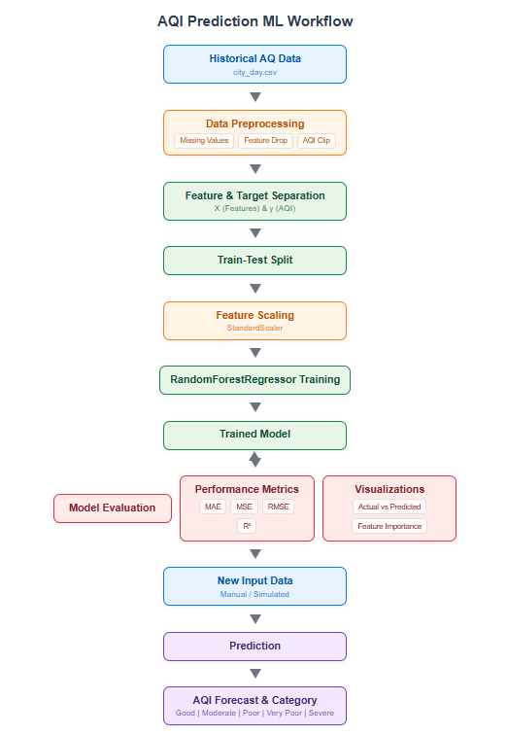

Description of Flow:

The process begins with Data Acquisition, where the historical city_day.csv dataset is loaded. This raw data then enters the Data Preprocessing stage, where it undergoes cleaning, transformation, and normalization to become suitable for machine learning algorithms. Following preprocessing, the data is split into features (X) and target (y), and then further divided into Training and Testing Sets. The RandomForestRegressor Model Training phase is where the chosen algorithm learns patterns from the training data. The resulting Trained Model is then subjected to Model Evaluation to assess its performance metrics and generalization ability. Finally, the validated model is deployed for Prediction on New Data, yielding an AQI Forecast along with its corresponding category.

Algorithms / Models

For this "Air Quality Index Prediction" project, the RandomForestRegressor algorithm has been strategically chosen as the primary Machine Learning model. This decision is based on its proven effectiveness in handling complex regression tasks, its robustness, and its ability to provide valuable insights into feature importance.

- RandomForestRegressor - A Deep Dive:

  - Ensemble Learning: Random Forest is a prime example of an ensemble learning method. Instead of relying on a single prediction model, it builds multiple individual prediction models (decision trees) and combines their results. This ensemble approach significantly improves the overall predictive accuracy and reduces overfitting compared to using a single decision tree.

  - Bagging (Bootstrap Aggregating): At its core, Random Forest utilizes a technique called bagging. During training, it creates multiple subsets of the training data by randomly sampling with replacement (bootstrapping). Each decision tree in the forest is then trained independently on one of these bootstrap samples.

  - Random Feature Subspace: In addition to bagging data, Random Forest also introduces randomness in feature selection. At each node of a decision tree, instead of considering all available features for the best split, it only considers a random subset of features. This "random feature subspace" further decorrelates the individual trees, making the ensemble more robust.

  - Prediction Aggregation: For a regression problem like AQI prediction, when a new data point needs to be predicted, each tree in the forest makes an individual prediction. The final output of the RandomForestRegressor is the average (or mean) of all these individual tree predictions.

- Justification for Choosing RandomForestRegressor for AQI Prediction:

  - Capturing Non-linear Relationships: Air quality is influenced by pollutants and meteorological factors in highly complex and often non-linear ways. Random Forests excel at capturing such intricate relationships without requiring explicit specification, unlike linear models.

  - Robustness to Overfitting: The ensemble nature, combined with random sampling of data and features, makes Random Forests highly resistant to overfitting, ensuring that the model generalizes well to unseen data.

  - Handling High-Dimensionality: The dataset, with its various pollutants, represents a moderately high-dimensional problem. Random Forests can efficiently handle a large number of input features.

  - Imputation of Missing Values (Implicitly): While explicit imputation is performed, Random Forests are generally robust to some level of noise and missing data (though direct NaN values must be handled).

  - Feature Importance Ranking: A key advantage is its ability to provide a ranking of feature importance. This helps in understanding which specific pollutants (e.g., PM2.5, NO2, CO) are the most critical drivers of AQI, offering valuable insights for environmental management and policy. This interpretability is often lacking in more complex "black-box" models.

  - Scalability: Random Forests are relatively scalable and can be parallelized (as indicated by n_jobs=-1 in the code), making them efficient to train on modern multi-core processors.

Workflow and Implementation Steps

The implementation follows a precise and well-defined workflow, executed entirely through Python scripts using powerful data science libraries. Each step is crucial for building a reliable predictive model:

- Data Acquisition (Loading Historical Data):

  - The project initiates by loading the city_day.csv dataset. This CSV file, containing historical daily air quality measurements from Indian cities, is read into a Pandas DataFrame.

  - A try-except block is implemented to gracefully handle FileNotFoundError, guiding the user if the dataset is not located in the expected path, thus improving the script's robustness.

- Initial Data Exploration and Inspection:

  - Basic Pandas functions such as data.head() (to view the first few rows), data.info() (to get a summary of the DataFrame, including data types and non-null counts), and data.describe() (to obtain statistical summaries like mean, std, min, max, quartiles for numeric columns) are used to gain preliminary insights into the dataset's structure and content.

- Missing Value Imputation:

  - The City, Date, and AQI_Bucket columns are explicitly dropped from the DataFrame. City and Date are not directly usable as numerical features without further transformation (e.g., one-hot encoding for city, time-series features for date), and AQI_Bucket is a categorical representation of the target variable (AQI).

  - A critical step involves handling missing NaN values. A loop iterates through all columns identified as numeric (float64, int64). For any such column containing NaN values, these are imputed (filled) with the mean of that respective column. This simple mean imputation strategy ensures that no NaNs are present, which would otherwise cause errors in subsequent machine learning steps.

- AQI Clipping:

  - To ensure the target variable AQI remains within a reasonable and defined range (0 to 500, as per standard AQI scales), np.clip() is applied to the AQI column. This handles any potential outliers or erroneous values that might fall outside this expected range.

- Feature (X) and Target (y) Separation:

  - The preprocessed DataFrame is logically divided into two parts:

    - X: The feature matrix, comprising all pollutant concentration columns (e.g., PM2.5, PM10, NO, CO) that will be used as input to the model. This is achieved by dropping the 'AQI' column.

    - y: The target vector, containing the corresponding AQI values that the model aims to predict.

- Storing Feature Names:

  - The exact names and order of the features in X are captured and stored in a list called X_feature_names_for_prediction. This is an essential step to guarantee consistency. During the prediction phase for new data, the input features must exactly match these names and their order to prevent ValueError due to feature mismatch.

- Train-Test Split:

  - The dataset (X and y) is partitioned into training and testing subsets using sklearn.model_selection.train_test_split. An 80% portion of the data is allocated for training the model (X_train, y_train), and the remaining 20% is reserved for evaluating its performance on unseen data (X_test, y_test). random_state=42 ensures reproducibility of the split.

- Feature Scaling:

  - sklearn.preprocessing.StandardScaler is employed to standardize the feature columns. This process transforms the data such that it has a mean of 0 and a standard deviation of 1. Scaling is crucial for many machine learning algorithms, as it prevents features with larger numerical ranges from disproportionately influencing the model's learning process. The scaler is fit on X_train and then used to transform both X_train and X_test.

- Model Initialization:

  - An instance of RandomForestRegressor is created. Key hyperparameters include n_estimators=100 (specifying the number of decision trees in the forest) and random_state=42 (for consistent results across runs). n_jobs=-1 is set to leverage all available CPU cores, thereby accelerating the training process.

- Model Training:

  - The model.fit(X_train_scaled, y_train) method is invoked. During this phase, the RandomForestRegressor algorithm learns the complex underlying patterns and relationships between the scaled pollutant concentrations (X_train_scaled) and their corresponding AQI values (y_train).

- Model Prediction (on Test Set):

  - After training, the model's predict() method is called with X_test_scaled (the unseen, scaled test features) to generate predictions (y_pred) for the AQI.

- Model Evaluation:

  - The generated y_pred is compared against the actual y_test values using several standard regression metrics:

    - Mean Absolute Error (MAE): The average of the absolute differences between predictions and actual values.

    - Mean Squared Error (MSE): The average of the squared differences between predictions and actual values, penalizing larger errors more heavily.

    - Root Mean Squared Error (RMSE): The square root of MSE, providing an error metric in the same units as the target variable (AQI).

    - R-squared (R2 Score): A statistical measure that represents the proportion of the variance in the dependent variable that is predictable from the independent variables. An R2 score closer to 1 indicates a better fit.

- Performance Visualization:

  - matplotlib.pyplot and seaborn libraries are utilized to create insightful visualizations:

    - A scatter plot of "Actual AQI vs. Predicted AQI" to visually assess the correlation and deviation of predictions from actual values. An ideal plot would show points clustered closely around a 45-degree line.

    - A bar plot displaying "Feature Importance" to rank and visualize the contribution of each pollutant feature to the AQI prediction, offering interpretability to the model.

- Prediction on New Data (Manual Example):

  - To demonstrate the model's practical utility, a sample DataFrame (new_air_data) is manually constructed with hypothetical pollutant concentrations.

  - Crucially, this new_air_data DataFrame is explicitly created to have the exact same column names and order as specified in X_feature_names_for_prediction from the training data. This strict matching prevents feature mismatch errors.

  - This new data is then scaled using the same scaler object that was fitted during the training phase.

  - The model.predict() method is then called on this scaled new data to generate AQI forecasts.

- AQI Categorization:

  - A helper function (get_aqi_category) takes the numerical AQI predictions and maps them to standard, descriptive AQI quality categories (e.g., "Good", "Satisfactory", "Poor"), making the predictions more easily understandable for end-users.

This methodical approach ensures that the "Air Quality Index Prediction using Machine Learning" project is built on sound data science principles, resulting in a robust, accurate, and interpretable predictive model.

Tools / Technologies / Hardware

This section details the various software tools, programming languages, libraries, and hardware components utilized in the development and execution of the "Air Quality Index Prediction using Machine Learning" project.

Software Tools and Platforms

- Python Environment: The core development environment is based on Python. This includes the Python interpreter itself.

- Jupyter Notebook / Visual Studio Code (VS Code):

  - Jupyter Notebook: Often used for its interactive and iterative development capabilities, allowing code, output, and explanatory text to be combined in a single document. Ideal for data exploration and rapid prototyping.

  - Visual Studio Code (VS Code): A lightweight, yet powerful, source code editor. It provides excellent support for Python development, including intelligent code completion, debugging, and integrated terminal access, making it suitable for writing and managing the project's Python scripts (.py files).

- Command Prompt / Terminal: Essential for managing the Python virtual environment (creating, activating, deactivating), installing necessary libraries using pip, and executing the Python project script.

- Google Docs: Used for compiling and formatting the project report, leveraging its collaborative features and word processing capabilities.

Programming Languages / Libraries

- Python (Programming Language):

  - Role: The foundational programming language for the entire project. Its readability, extensive ecosystem of scientific libraries, and strong community support make it ideal for machine learning and data science tasks.

- NumPy:

  - Role: A fundamental library for numerical computing in Python. It provides support for large, multi-dimensional arrays and matrices, along with a collection of high-level mathematical functions to operate on these arrays. It is extensively used for efficient numerical operations within the data preprocessing and model training phases.

- Pandas:

  - Role: A powerful and flexible open-source data analysis and manipulation library. It is crucial for handling structured data, primarily DataFrames. Its functionalities are used for reading the city_day.csv file, data inspection (.head(), .info(), .describe()), handling missing values (.fillna()), dropping columns (.drop()), and data selection.

- Scikit-learn (sklearn):

  - Role: A comprehensive and widely used open-source machine learning library for Python. It provides a wide range of supervised and unsupervised learning algorithms. Key components used in this project include:

    - sklearn.model_selection.train_test_split: For dividing the dataset into training and testing subsets.

    - sklearn.preprocessing.StandardScaler: For standardizing (scaling) numerical features.

    - sklearn.ensemble.RandomForestRegressor: The core machine learning algorithm chosen for AQI prediction.

    - sklearn.metrics: For calculating evaluation metrics such as mean_absolute_error, mean_squared_error, and r2_score.

- Matplotlib:

  - Role: A robust and versatile Python plotting library. It is used for creating static, interactive, and animated visualizations. In this project, it's used to generate scatter plots (Actual vs. Predicted AQI) and bar plots (Feature Importance).

- Seaborn:

  - Role: A high-level data visualization library based on Matplotlib. It provides a more user-friendly interface for drawing attractive and informative statistical graphics. It enhances the visual appeal and clarity of the plots generated for model evaluation.

- Requests (Optional for API Integration):

  - Role: (If API integration for real-time data is implemented, as discussed previously). This library simplifies making HTTP requests to fetch data from web APIs, such as the AQICN API, for dynamic data acquisition.

- JSON (Optional for API Integration):
  - Role: (If API integration is used). This built-in Python library is used for parsing JSON (JavaScript Object Notation) formatted data, which is a common format for data exchanged via web APIs.

Hardware / Devices (if applicable)

The project can be executed on standard personal computing hardware. The following specifications represent a typical setup suitable for this project's computational demands:

- Processor (CPU): Intel Core i5 or i7 (or equivalent AMD Ryzen 5/7) processor. A multi-core CPU (e.g., 4 cores or more) is beneficial, especially when using n_jobs=-1 with RandomForestRegressor for parallel processing during training.

- Random Access Memory (RAM): 8 GB of RAM or more is recommended. Sufficient RAM ensures smooth handling of the dataset (approx. 30,000 entries with 12-15 features) and prevents performance bottlenecks during data preprocessing and model training.

- Storage: A Solid State Drive (SSD) with 256 GB or more capacity is preferable for faster operating system boot times, software loading, and quick access to project files. A Hard Disk Drive (HDD) is also sufficient but slower.

- Operating System: Windows 11 (as per user's current system). The Python environment and libraries are cross-platform compatible, so macOS or Linux environments would also be suitable.

Tentative Timeline and Work Plan

This section outlines the planned schedule and workflow for the "Air Quality Index Prediction using Machine Learning" project. It breaks down the project into distinct phases, specifying key activities, expected deliverables, and a tentative timeline for completion. This plan serves as a roadmap to ensure systematic progress and timely achievement of project objectives.

Milestones and Deliverables
The project follows a systematic, phase-based approach with clearly defined milestones and measurable deliverables. Each phase builds upon the previous one, ensuring progressive development and quality outcomes.

- Project Timeline Overview

  - Total Project Duration: 22 weeks
  - Number of Phases: 7 sequential phases
  - Approach: Iterative development with milestone-driven progress tracking

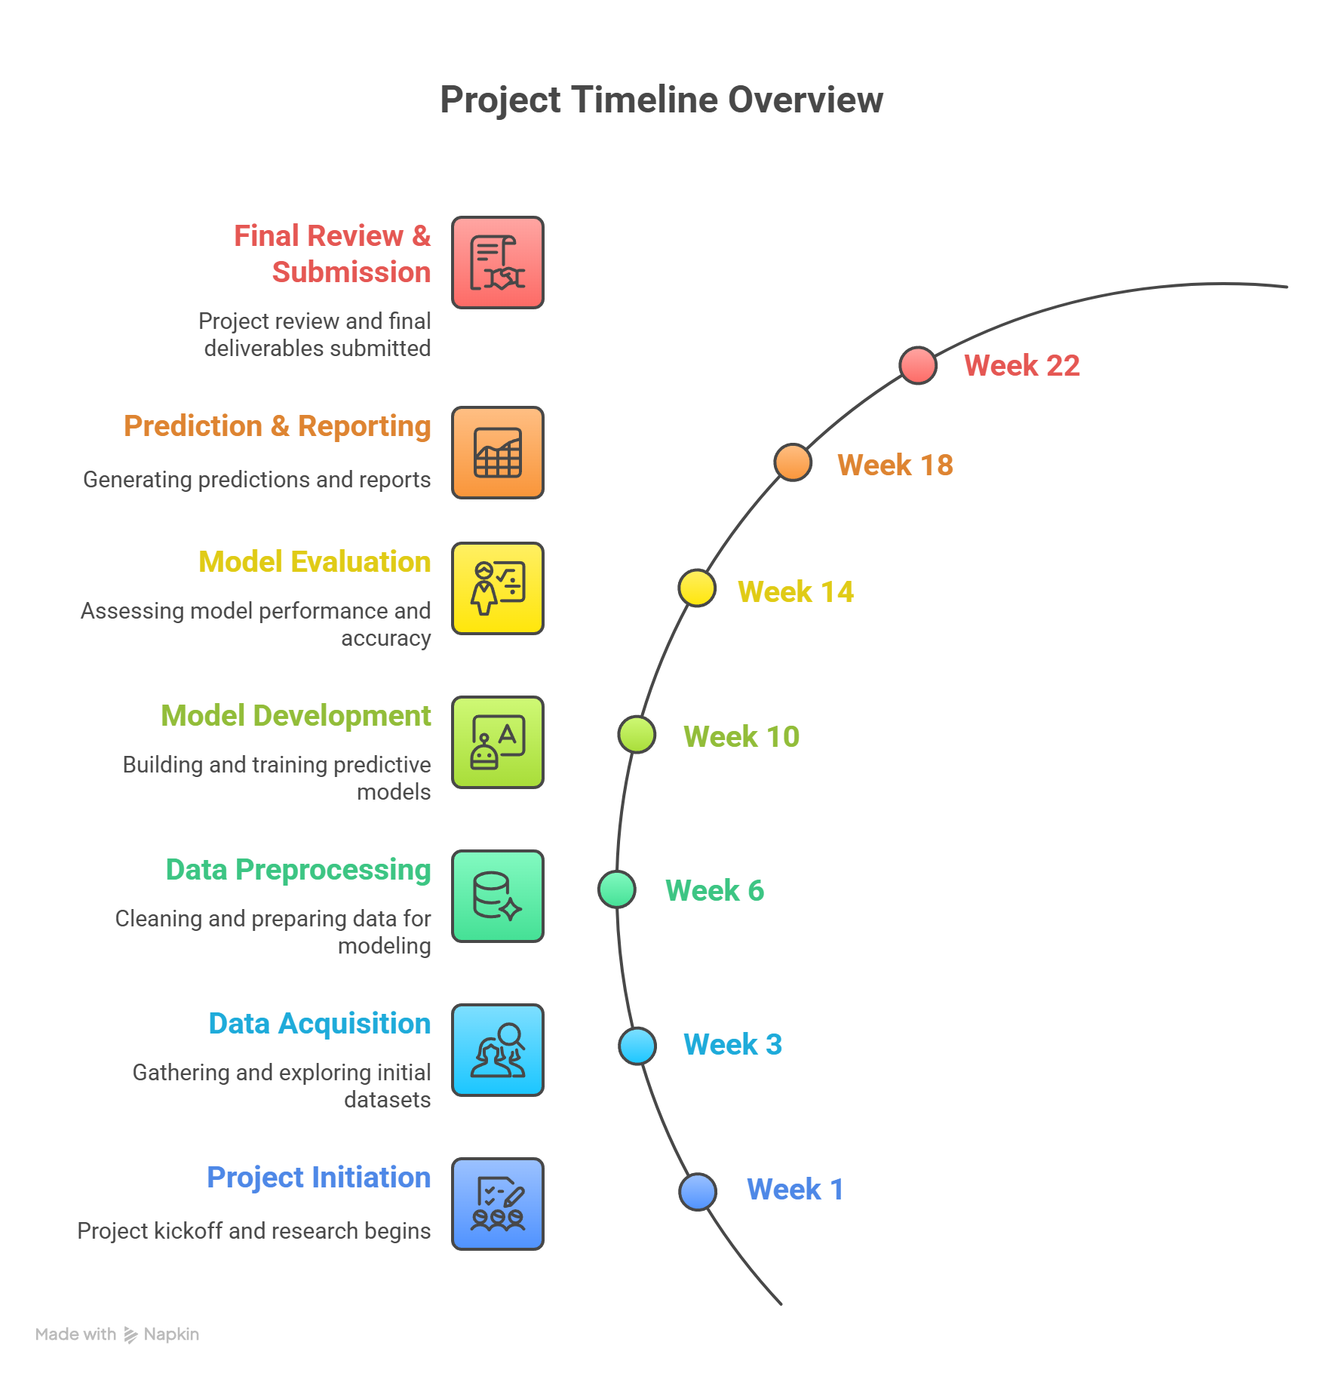

- Phase-wise Breakdown

  - Phase 1: Project Initiation & Research
Duration: 2 weeks
Objective: Establish project foundation and conduct comprehensive background research

    - Key Activities:
      - Project definition and scope finalization
      - Comprehensive literature review and problem analysis
      - Gap identification and needs assessment

    - Deliverables:
      - ✅ Project Proposal Document - Complete project charter with objectives, scope, and methodology
      - ✅ Research Notes & Analysis - Documented gaps, needs assessment, and literature findings

  - Phase 2: Data Acquisition & Exploration
Duration: 3 weeks
Objective: Obtain and perform initial analysis of the city_day.csv dataset

    - Key Activities:
      - Dataset download and loading into Pandas DataFrame
      - Initial data inspection using .head(), .info(), and .describe() methods
      - Missing values identification and data type analysis

    - Deliverables:
      - ✅ Loaded Raw Dataset - city_day.csv successfully imported as Pandas DataFrame
      - ✅ Initial Data Overview Report - Comprehensive summary of dataset characteristics
      - ✅ Missing Values Analysis Report - Detailed assessment of data quality issues

  - Phase 3: Data Preprocessing
Duration: 4 weeks
Objective: Clean and prepare data for machine learning model training

    - Key Activities:
      - Missing value treatment using mean imputation strategy
      - Removal of irrelevant columns (City, Date, AQI_Bucket)
      - AQI value validation and clipping to 0-500 range
      - Feature-target variable separation

    - Deliverables:
      - ✅ Cleaned Dataset - NaN-free, processed dataset ready for modeling
      - ✅ Feature-ready Dataset - Optimized feature set with irrelevant columns removed
      - ✅ Validated AQI Target Variable - Quality-assured target variable within valid range
      - ✅ X (Features) & y (Target) DataFrames - Properly separated independent and dependent variables

  - Phase 4: Model Development & Training
Duration: 5 weeks
Objective: Develop, configure, and train the machine learning model

    - Key Activities:
      - Train-test dataset splitting (80/20 ratio)
      - Feature scaling using StandardScaler
      - RandomForestRegressor selection and configuration
      - Model training and hyperparameter optimization

    - Deliverables:
      - ✅ Training and Testing Datasets - Properly partitioned data for model development
      - ✅ Scaled Training & Testing Data - Normalized features for optimal model performance
      - ✅ Algorithm Justification Document - Rationale for RandomForestRegressor selection
      - ✅ Configured ML Model Instance - Initialized model with optimized parameters
      - ✅ Trained RandomForestRegressor Model - Fully trained model ready for evaluation

  - Phase 5: Model Evaluation & Analysis
Duration: 3 weeks
Objective: Assess model performance and analyze results comprehensively

    - Key Activities:
      - Test set predictions generation
      - Performance metrics calculation (MAE, MSE, RMSE, R²)
      - Actual vs. predicted values visualization
      - Feature importance analysis and visualization

    - Deliverables:
      - ✅ Predicted AQI Values (y_pred) - Model predictions on test dataset
      - ✅ Quantitative Evaluation Metrics Report - Complete performance assessment with statistical measures
      - ✅ Performance Scatter Plot - Visual representation of actual vs. predicted values
      - ✅ Feature Importance Analysis - Bar plot and detailed analysis of variable significance

  - Phase 6: Prediction & Reporting
Duration: 3 weeks
Objective: Demonstrate practical application and compile comprehensive documentation

    - Key Activities:
      - New data prediction demonstrations
      - AQI value categorization and interpretation
      - Comprehensive report drafting and formatting

    - Deliverables:
      - ✅ AQI Forecasts for Sample Inputs - Practical prediction examples with real-world scenarios
      - ✅ Categorized AQI Results - Interpreted predictions with air quality classifications
      - ✅ Comprehensive Project Report (Draft) - Complete documentation of methodology and findings

  - Phase 7: Final Review & Submission
Duration: 2 weeks
Objective: Finalize documentation and prepare for project presentation

    - Key Activities:
      - Report review, refinement, and quality assurance
      - Presentation material preparation
      - Final formatting and submission preparation

    - Deliverables:
      - ✅ Final Project Report - Complete, formatted, and reviewed documentation
      - ✅ Project Presentation Slides - Professional presentation materials for project defense

- Success Metrics
Each phase includes specific quality gates and acceptance criteria to ensure deliverable completeness:

- Technical Quality: All code implementations must be documented and tested
- Documentation Standards: Reports must include methodology, results, and interpretations
- Reproducibility: All analyses must be replicable with provided code and data
- Academic Rigor: Literature citations and methodology justifications required

- Risk Management
Identified Risks & Mitigation Strategies:

- Data Quality Issues: Built-in data validation and multiple preprocessing steps
- Model Performance: Multiple evaluation metrics and cross-validation approaches
- Timeline Delays: Buffer time allocated in each phase for unexpected challenges

This structured approach ensures systematic progress tracking and high-quality deliverables at each project milestone.

Gantt Chart / Schedule

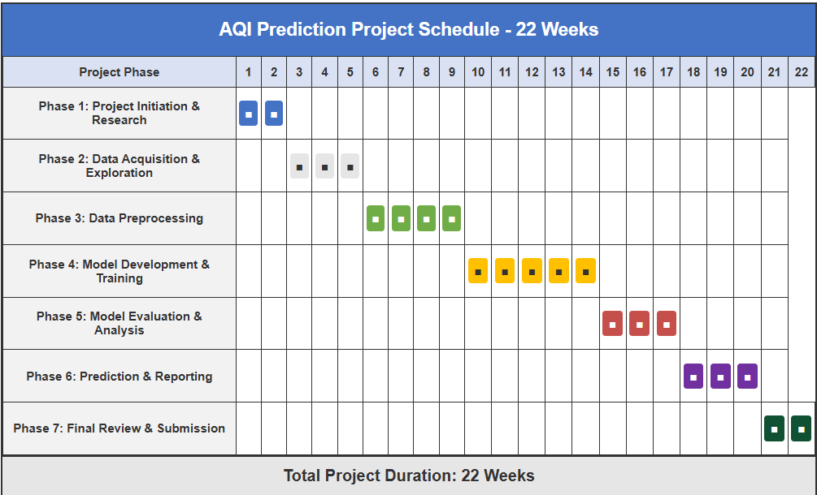

- Total Project Duration: 22 Weeks

  - Week 1-2: Phase 1 - Project Initiation & Research
- Define Project Goal & Scope.
- Conduct Literature Review on AQI Prediction.
- Understand problem challenges and existing solutions.

  - Week 3-5: Phase 2 - Data Acquisition & Exploration

- Download and acquire city_day.csv dataset.
- Load dataset into Python using Pandas.
- Perform initial data inspection (head, info, describe).
- Analyze and document missing values.
- Visualize key data distributions and relationships (if applicable).

  - Week 6-9: Phase 3 - Data Preprocessing
- Implement mean imputation for all missing numerical values.
- Drop irrelevant columns (City, Date, AQI_Bucket).
- Clip AQI values to a standard range (0-500).
- Separate features (X) and target (y).

  - Week 10-14: Phase 4 - Model Development & Training
- Split data into training and testing sets.
- Apply StandardScaler for feature scaling.
- Initialize and configure RandomForestRegressor.
- Train the RandomForestRegressor model on scaled training data.

  - Week 15-17: Phase 5 - Model Evaluation & Analysis
- Make predictions on the test set.
- Calculate and analyze MAE, MSE, RMSE, and R2 scores.
- Generate and interpret "Actual vs. Predicted AQI" scatter plot.
- Calculate and visualize "Feature Importance".

  - Week 18-20: Phase 6 - Prediction & Reporting
- Set up and execute predictions on new, simulated data.
- Categorize predicted AQI values.
- Begin drafting the project report, detailing all methodologies, findings, and discussions.

  - Week 21-22: Phase 7 - Final Review & Submission
- Thoroughly review, edit, and refine the entire project report for clarity, grammar, and adherence to formatting guidelines.
- Prepare a compelling project presentation.
- Finalize all project deliverables for submission.
- This detailed timeline provides a structured approach to project execution, ensuring that each phase is adequately addressed and managed effectively.

Expected Outcomes

This section delineates the anticipated results and benefits stemming from the successful completion of the "Air Quality Index Prediction using Machine Learning" project. It outlines both the tangible technical achievements and the broader academic, social, and business impacts.

Technical Outcomes
Upon successful completion, this project is expected to yield the following technical outcomes:

- Robust Machine Learning Model: Development and implementation of a well-trained RandomForestRegressor model capable of accurately predicting the Air Quality Index (AQI) based on a diverse set of pollutant concentrations. The model will demonstrate high predictive performance, evidenced by an R2 Score of approximately 0.90, and low error rates (MAE ~18.47, RMSE ~32.72).

- Clean and Prepared Dataset: A thoroughly preprocessed historical air quality dataset (city_day.csv), free from missing values and scaled appropriately, making it suitable for advanced analytical and machine learning applications.

- Comprehensive Python Codebase: A clean, modular, and well-documented Python codebase (aqi_prediction.py) encapsulating the entire machine learning pipeline, from data loading and preprocessing to model training, evaluation, and prediction.

- Data-Driven Insights: Generation of actionable insights through feature importance analysis, identifying the most influential pollutant parameters (e.g., PM2.5, PM10, O3, NO2) that contribute significantly to AQI fluctuations.

- Visualization Tools: Production of clear and informative visualizations, including scatter plots comparing actual vs. predicted AQI, and bar charts illustrating feature importance, to aid in model interpretation and performance communication.
- Prediction Functionality: A functional system capable of taking new, unseen pollutant data as input and generating immediate AQI forecasts along with their respective air quality categories.

Academic / Social / Business Impact

The successful execution of this project is poised to generate significant impacts across academic, social, and business spheres:

- Academic Impact:

- Practical Application of ML: Serves as a tangible case study demonstrating the practical application of supervised machine learning (regression) techniques to a real-world environmental problem.

- Knowledge Contribution: Contributes to the growing body of knowledge in environmental data science and predictive analytics, offering insights into effective methodologies for AQI forecasting.

- Educational Resource: The documented code and report can serve as an educational resource for students and researchers interested in machine learning, environmental monitoring, and data preprocessing best practices.

- Social Impact:

- Enhanced Public Health Awareness: Provides a foundation for developing tools that can offer early warnings about deteriorating air quality, empowering citizens (especially vulnerable populations) to take proactive measures to protect their health.

- Informed Decision-Making: Supports public health officials and environmental agencies with data-driven forecasts, enabling more effective policy formulation and timely interventions to mitigate air pollution.
- Community Engagement: Can foster greater public engagement and understanding of local air quality issues, promoting collective action towards a healthier environment.

- Business Impact:

- Smart City Integration: Offers a core component that can be integrated into smart city platforms, enabling more intelligent environmental monitoring and management systems for urban areas.

- Environmental Consulting & Analytics: Provides a robust predictive tool that can be adopted by environmental consulting firms to offer advanced forecasting services to clients.

- Health-Tech Solutions: Can be incorporated into health and wellness applications that provide personalized environmental impact assessments and recommendations to users, adding significant value to health-tech offerings.

- Resource Optimization: Businesses and public utilities reliant on air quality data can optimize operations, such as energy consumption in pollution control, based on accurate forecasts.

- Risk Management: Aids industries in proactive risk management related to environmental compliance and public relations by anticipating periods of high pollution.

Ethical, Legal, and Environmental Considerations

The deployment of a Machine Learning-based Air Quality Index (AQI) prediction system, while promising immense benefits for public health and environmental management, also introduces a complex array of ethical, legal, and environmental considerations. A responsible approach to such a project necessitates a thorough examination of these factors to ensure that the technology serves humanity and the environment ethically, legally, and sustainably.

Ethical Concerns

Ethical considerations are paramount in any system that provides information impacting public welfare. For AQI prediction, these include:

- Accuracy, Reliability, and Risk of Misinformation:

  - Core Concern: The most critical ethical dilemma revolves around the accuracy and reliability of the predictions. An overly optimistic forecast during a period of high pollution (a false negative) could lead the public to underestimate health risks, resulting in increased exposure and adverse health outcomes. Conversely, an unduly pessimistic forecast (a false positive) could generate unnecessary panic, disrupt daily life, and lead to economic losses without genuine justification.

  - Mitigation: It is ethically imperative to rigorously evaluate the model's performance, understand its limitations, and communicate prediction uncertainties transparently. Providing confidence intervals or probabilistic forecasts, rather than just single-point predictions, can offer a more nuanced and ethically sound approach. Continuous monitoring and recalibration of the model are also essential.

- Transparency, Explainability, and Trust:

  - Core Concern: Machine Learning models, particularly complex ensemble methods like RandomForestRegressor, can sometimes operate as "black boxes," making it challenging to understand why a specific prediction was made. This lack of transparency can erode public trust, especially if predictions contradict intuitive understanding or existing reports.

  - Mitigation: Efforts should be made to enhance model explainability. Tools like Feature Importance (as demonstrated in this project) provide a degree of interpretability by showing which pollutants are most influential. For deployment, providing explanations alongside predictions (e.g., "AQI is predicted to be high primarily due to elevated PM2.5 levels") can foster trust and empower users to act.
- Data Bias and Fairness:
  - Core Concern: The historical data (city_day.csv) used for training, although publicly available, might inherently contain biases. These could stem from non-uniform placement of monitoring stations (e.g., more stations in affluent areas, fewer in marginalized communities), differing sensor quality, or inconsistent reporting across regions. If the training data is biased, the model's predictions may also be biased, potentially under-predicting pollution in underserved areas or over-predicting in others, thus exacerbating environmental injustices.

  - Mitigation: Future work should include a thorough analysis of data representativeness. Efforts to collect more equitable and comprehensive data, or to apply fairness-aware machine learning techniques, would be ethically beneficial. For this project, a clear acknowledgement of potential data biases in the chosen dataset is important.

- Responsible Deployment and Use:

  - Core Concern: The predictive system is a tool meant to aid, not replace, human judgment and regulatory oversight. There is an ethical responsibility to ensure that the tool is not misused for malicious purposes (e.g., manipulating information) or relied upon blindly without critical assessment.

  - Mitigation: Clear guidelines for its use by authorities, researchers, and the public must be established. The system should be integrated into broader environmental management frameworks that include human review and expert validation.

Legal Compliance

Adherence to legal frameworks is crucial for the legitimate operation and societal acceptance of any data-driven system.

- Data Sourcing, Licensing, and Attribution:

  - Compliance: The city_day.csv dataset from Kaggle is generally available under open licenses (e.g., Creative Commons Attribution 4.0 International License), which permits sharing and adaptation, provided appropriate attribution is given to the original creator (Rohan Rao and CPCB). For academic projects, this is usually sufficient. However, for any commercial application, strict verification of the specific license terms is mandatory.

  - Requirement: Any public-facing application utilizing this data or predictions derived from it must clearly acknowledge the data source and adhere to attribution requirements to ensure legal compliance.

- Data Protection and Privacy:

  - Current Project: The current project primarily uses aggregated, publicly available environmental data. It does not collect or process personally identifiable information (PII) from individuals. Therefore, stringent personal data protection regulations like Europe's General Data Protection Regulation (GDPR) or India's Digital Personal Data Protection (DPDP) Bill, 2023, are not directly applicable to the core model's data processing.

  - Future Expansions: Should the project expand to include user-specific data (e.g., location tracking for personal exposure analysis, demographic information), robust data protection measures, privacy-by-design principles, and full compliance with relevant data privacy laws would become absolutely essential.

- Accuracy, Warranties, and Liability Disclaimers:
  - Compliance: Predictive models, by their nature, are probabilistic and not infallible. It is a legal necessity to provide clear disclaimers that the AQI forecasts are predictions and not certified measurements or guarantees. This helps manage public expectations and limits the liability of the developers and deployers in case of forecast inaccuracies.

  - Requirement: Any user interface or official communication stemming from this prediction system must prominently display such disclaimers, outlining that the information is for guidance and informational purposes only.

- Environmental Reporting and Regulatory Alignment:

  - Compliance: While the model predicts AQI, it does not replace official air quality monitoring and reporting mandated by environmental agencies (like CPCB). The model's predictions should ideally be aligned with the AQI calculation methodologies and reporting standards set by such regulatory bodies to ensure consistency and utility.

  - Assistance: The system can legally assist regulatory bodies by providing supplementary predictive insights, but it must operate within the existing legal framework for environmental monitoring and public disclosure.

Environmental Impact

The very nature of this project directly relates to environmental concerns, with a predominantly positive impact, alongside a minor computational footprint.

- Positive Environmental Impact:

  - Proactive Pollution Mitigation: The most significant environmental benefit is the ability to enable proactive rather than reactive responses to air pollution. By predicting high AQI days, authorities can implement timely interventions (e.g., advising industries to reduce emissions, promoting public transport, limiting construction activities) to prevent severe pollution episodes, leading to a direct improvement in air quality.

  - Resource Optimization for Environmental Protection: Accurate forecasts allow for more efficient allocation of resources dedicated to environmental protection. For instance, deploying mobile monitoring units or focused awareness campaigns to areas predicted to have poor air quality can maximize their impact.

  - Informed Urban Planning: Insights derived from feature importance (e.g., identifying primary pollutants) can guide long-term urban planning and industrial policy towards more sustainable practices, helping to design cities that naturally have better air quality.

  - Increased Public Engagement: Enhanced awareness due to predictive capabilities can empower citizens to advocate for and participate in environmental protection initiatives, leading to stronger community-led environmental efforts.

- Computational Footprint (Minor Negative Impact):

  - Energy Consumption: Training and running machine learning models, especially complex ones, require computational power, which consumes electricity. This energy consumption contributes to the overall carbon footprint. For a RandomForestRegressor with a moderately sized dataset (like city_day.csv), this impact is relatively minor. However, in the context of large-scale deployments, continuous real-time predictions, or retraining on massive datasets, the energy consumption needs to be considered.

  - Mitigation: To minimize this impact, the project leverages efficient libraries (Scikit-learn) and parallel processing (n_jobs=-1). Future optimizations could involve using more computationally efficient models where appropriate, optimizing code for lower energy consumption, or utilizing energy-efficient cloud infrastructure. The environmental benefits derived from better air quality management are expected to significantly outweigh the computational costs.

In summary, the "Air Quality Index Prediction using Machine Learning" project strives to be a beneficial environmental tool, developed with an awareness of its ethical obligations, operating within legal boundaries, and aiming to make a substantial positive contribution to environmental health.

